Increased bird sound diversity in vineyards enhances visitors’ tour experience.
Natalia B. Zielonkaª, Victoria Tubmanª, Lynn V. Dicks^{a,b*} & Simon J. Butler^{a*}
ª School of Biological Sciences, University of East Anglia, Norwich, UK, NR4 7TJ
^{b} Department of Zoology, University of Cambridge, UK, CB2 3EJ

Corresponding author: Natalia Zielonka, natalia_b_zielonka@outlook.com
* Joint senior authors
Keywords: aesthetic value, birdsong, soundscapes, nature connectedness, agriculture, cultural services

Abstract
- Biodiversity is rapidly declining, reducing the quantity and quality of human interactions with nature and constraining its contribution to human health and wellbeing. Natural sounds are a key component of our experience of nature, but biodiversity losses are reflected in soundscapes, which are becoming less diverse and quieter.
- We characterised the soundscapes across 21 English vineyards using acoustic indices and related them to bird species richness and abundance. We found that higher bird species richness, but not abundance, led to more diverse and louder soundscapes, as reflected in higher values of Acoustic Complexity Index (ACI), Bioacoustic Index (BIO) and Normalised Difference Soundscape Index (NDSI), and lower values of Acoustic Entropy Index (H).
- Secondly, at three of the study vineyards that run vineyard tours, we measured visitors’ experience of the tour in terms of sound enjoyment, soundscape connectedness and tour satisfaction, and related these to ambient and experimentally enhanced soundscapes, where we used playback recordings of five additional birdsongs to increase the soundscapes’ complexity and volume.
- Under ambient conditions, respondents’ (n=107) experience was significantly higher at sites with soundscapes that had higher ACI and BIO values, and lower H, Acoustic Diversity Index (ADI) and NDSI values, indicating a positive effect of more diverse and louder soundscapes. Natural sounds formed an important part of the tour experience at these sites, making visitors feel more present and connected to nature.
- Under experimental soundscape enhancement, respondents (n=79) reported hearing significantly more bird species during the tour, and they reported significantly higher scores for sound enjoyment, soundscape connectedness and tour satisfaction than under ambient conditions. This effect was stronger in visitors who engaged more in pro-environmental behaviours, such as purchasing organic foods.
- Our study demonstrates (i) the direct contribution of aural modes to our experience of nature and (ii) that the delivery of biodiversity conservation measures aimed at supporting bird diversity could simultaneously enhance the experience and wellbeing benefits of spending time in nature. Natural soundscapes should therefore be recognised and valued as natural capital, and their protection should be incorporated into conservation planning and policy.

Acknowledgements
We sincerely thank our study vineyards’ managers and employees for access to field sites, in-field logistics, for providing management information, and their support and interest in our research. We thank WineGB and SWGB, and Chris Foss in particular, for their help in setting up this project and for supporting our research. We are grateful to two anonymous reviewers for their helpful comments on the manuscript. The UKRI Biotechnology and Biological Sciences Research Council Norwich Research Park Biosciences Doctoral Training Partnership provided financial support to Natalia Zielonka (grant code BB/M011216/1), the UKRI Natural Environment Research Council provided financial support to Simon Butler (NE/X002055/1) and Lynn Dicks (NE/N014472/1 and NE/N014472/2), and Victoria Tubman was supported through the University of East Anglia and Sustainable Wine of Great Britain scholarship.

Author contributions
NBZ (lead), VT (lead on vineyard tour study), SJB (supporting) and LVD (supporting) conceived the study and designed the methodology; NBZ (lead) collected and curated the acoustic data and VT (lead) and NBZ (supporting) ran the vineyard tour study; NBZ (lead) and SJB (supporting) analysed the data; NBZ (lead) drafted the manuscript; VT, SJB and LVD reviewed and edited the manuscript; SJB (lead) and LVD (supporting) provided supervision; LVD (lead) acquired the funding for NZ, and VT (lead), NZ (supporting) and SJB (supporting) acquired the funding from SWGB.

Conflict of interest statement
The authors declare that they have no conflict of interest.

- Introduction
The Anthropocene is characterised by continual and pervasive biodiversity declines (Díaz et al., 2019; IPBES, 2019), with agriculture being a leading driver (Inger et al., 2015; Reif & Vermouzek, 2019; Rigal et al., 2023). These decline, together with growing urbanisation and changing lifestyles, which have become increasingly sedentary, are reducing the likelihood of human interactions with nature (Díaz et al., 2015; Klepeis et al., 2001; Soga & Gaston, 2016). The growing human disconnect from nature is therefore fuelling an ‘extinction of experience’ (Cox & Gaston, 2018; Gaston & Soga, 2020), lessening nature’s contributions to our physical and psychological health and culture (Bratman et al., 2019; Gaston & Soga, 2020; IPBES, 2019), with potentially serious consequences for human health and wellbeing. For example, time spent in nature has been shown to lower the risk of developing cardiovascular and respiratory diseases (Richardson & Mitchell, 2010) and diabetes (Astell-Burt & Feng, 2019), and benefitting mental wellbeing and happiness (Capaldi et al., 2014; Engemann et al., 2019; Joye and Bolderdijk, 2015). In the United Kingdom, ‘time in nature’ is even prescribed by health professionals (NHS England, n.d.) and considered in governmental policies (DEFRA, 2020) as being crucial for the country’s wellbeing. To maximise the benefits arising from interactions with nature, we need to firstly understand how different modes of experience contribute to human wellbeing, and secondly, how such benefits could be enhanced through conservation measures.
Landscapes emanate a collection of biological, geophysical and anthropogenic sounds which together form ‘soundscapes’ (Pijanowski et al., 2011), and soundscapes are in turn experienced and perceived by people (Ratcliffe, 2021). Sounds affect our interactions with nature (Buckley, 2022), with laboratory studies showing greater enjoyment of higher diversity soundscapes (Douglas and Evans, 2022), and that listening to natural sounds promotes mood recovery (Benfield et al., 2014) and perceived restoration (Smalley et al., 2022). Birdsong is a dominant component of natural soundscapes, particularly in temperate regions (Gasc et al., 2017; Uebel et al., 2021), and birdsong diversity has been shown to influence our appreciation of landscapes (Hedblom et al., 2014), and perceived restoration and wellbeing (Fisher et al., 2021). Ferraro et al. (2020) showed that the experimental enhancement of natural soundscapes using playback of constructed birdsong choruses along hiking routes delivered higher levels of self-reported psychological restoration in hikers. However, a similar laboratory-based study failed to find an improvement in self-reported restoration following a playback of high avian diversity soundscape (Douglas & Evans, 2022), suggesting that perhaps the effects of sounds and the sight of natural landscape interact with the act of physical activity to deliver wellbeing benefits. The staggering and ongoing declines of bird populations and concurrent homogenisation of assemblages (Burns et al., 2021; Johnson et al., 2017; Olden et al., 2004; Rosenberg et al., 2019), translate to reductions in birdsong abundance and diversity, and underpin reported large-scale declines in natural soundscape quality (Morrison et al. 2021), with associated implications for derived health and wellbeing benefits.
Farmland bird species have experienced some of the largest population declines (Inger et al., 2015; Reif & Vermouzek, 2019; Rigal et al., 2023). In the United Kingdom, the State of Nature 2023 Report stated that 43% of bird species are threatened with local extinction, based on national IUCN red list assessments (Burns et al., 2023), whilst the Farmland Bird Index shows 60% decline since its 1970 value (DEFRA, 2022). Viticulture is the UK’s fastest growing agricultural sector, attributed to global warming improving the climate for grape growing (Nesbitt et al., 2019). European vineyards have been shown to have detrimental effects on bird (Assandri et al., 2016; Pithon et al., 2016), and wider diversity (e.g. Geldenhuys et al., 2022) but the scale of impact is significantly influenced by vineyard practices (Paiola et al., 2020; Zielonka et al., 2024), and the introduction of targeted management can support high abundances of threatened and endemic avifauna within vineyards (Brambilla et al., 2017). Though fundamentally agricultural systems, vineyards are associated with tourism through vineyard tours and tastings events, with tourism contributing 24% of the total revenue across the UK viticulture industry (WineGB, 2023). Earlier this year, Sussex Modern, funded by the UK Government, launched a plan to support the development of the wine tourism industry, which it is estimating could be worth £658 million by 2040 and contribute over 26% to the local tourism industry (Sussex Modern, 2023). Soundscapes are an important part of the tourism experience (e.g. Fesenko and García-Rosell, 2019), where higher sound complexity has been shown to correlate positively with improved wellbeing (Fisher et al., 2021), whilst positive soundscape perception has been linked to higher tourism loyalty (Jiang & Yan, 2022). This presents an opportunity for informing how soundscape conservation could support the development of vineyard tourism and contribute to the wider industry goals of sustainability and protection of the local landscapes and livelihoods (Sussex Modern, 2023; SWGB, 2020).
Here we investigated the relationship between bird diversity and soundscape characteristics in vineyards, and linked these to visitors’ experience of vineyard tours to further our understanding of the role that soundscapes play in affecting human experience. Our aims were to: (1) quantify the relationships between bird diversity metrics and acoustic indices in UK vineyards; (2) relate visitors’ experience of vineyard tours to ambient soundscape conditions; (3) test whether experimental soundscape enhancement affected visitors’ perception of vineyards’ biodiversity; and (4) test whether experimental soundscape enhancement affected visitors’ experience of the vineyard tour. We predicted that bird diversity would be reflected in acoustic indices, and that visitors’ experience would be related to soundscape characteristics. We predicted that visitors subjected to soundscape enhancement would perceive the vineyards’ biodiversity as being higher, and report improved tour experience.
- Materials and methods
  - Bird diversity and acoustic monitoring
We performed acoustic monitoring and bird surveys across 21 English vineyards in 2021 and 2022. In each year, data collection took place across the three key seasons of the vine lifecycle: ‘budding’ (April-May), ‘flowering’ (June-August), and ‘harvest’ (September-October). We performed monitoring at 32 locations across the 21 vineyards, with one sampling location across 12 sites (average vineyard size 5.78 ± 2.12 SE ha), two sampling locations across seven sites (45.45 ± 1.68 ha) and three sampling locations across two sites (72.72 ± 6.73 ha). Sampling locations were within vine fields, at least 50 m from boundary habitats and a minimum of 250 m apart (see supporting information 1 for a map).
    - Active bird surveys
Bird communities in vineyards were assessed with 10-minute point counts. At each monitoring location (n=32), we performed one point count in each of the ‘budding’, ‘flowering’ and ‘harvest’ seasons in 2021 and in 2022 (as described in Zielonka et al., 2024). Point count surveys were conducted between 05:00 – 09:00 and within 3 hours of sunrise, and all birds seen and heard within a 50 m radius were recorded, excluding birds flying over. Surveys only took place on dry and still days (Bibby et al., 2000), and were performed by the same observer.
    - Acoustic data
At the same monitoring locations as covered by bird surveys, we recorded soundscapes using AudioMoths (Hill et al., 2019), with the sampling rate set to 96 kHz and medium gain. Ten-minute recordings were taken on the hour between 05:00 – 07:10 (‘morning period’) and 18:00 – 20:10 (‘evening period’) each day, when bird vocal activity was expected to be highest, giving six 10-minute recordings in each 24-hour period. AudioMoths were placed in clear plastic bags and mounted to metal trellis poles present across all vineyards, at the height of 2 meters, with the microphone facing up. This placement ensured that AudioMoths were placed above the vine canopy cover, which could obstruct the clarity of recordings. Devices were deployed twice each year, firstly at ‘budding’, and then re-deployed at ‘flowering’, before being collected at ‘harvest’. Recordings were collected between 13th April – 11th June and 28th June – 18th September in 2021 (1,553 recording days and 9,039 10-minute recordings), and between 2nd April – 16th July 2022 (915 recording days and 5,009 ten-minute recordings). We did not make any recordings beyond 16th July in 2022 as all devices failed due to the extreme heat (Kendon, 2022). On average, data were collected on 50.15 recording days ± 1.90 SE per device and per deployment in each year and was mostly dependent on battery life. Over the two years, 8 devices were either lost or destroyed.
All sound file processing was performed in R 4.3.0 (R Core Team, 2021). Using the package seewave (Sueur et al., 2008), we down-sampled the recordings to 44.1 kHz (following Bradfer-Lawrence et al., 2019) and split the 10-minute recordings to 1-minute sub-samples (0 – 59 seconds, 60-119 seconds etc.). Using the packages seewave and soundecology (Sueur et al., 2008; Villanueva-Rivera & Pijanowski, 2018), we quantified soundscapes using five commonly used indices that capture a range of acoustic characteristics and have been found to be reflective of biodiversity (Alcocer et al., 2022; Bradfer-Lawrence et al., 2023). Specifically, we calculated Acoustic Complexity Index (ACI, Pieretti et al., 2011), where higher values indicate irregularity in acoustic energy across frequencies and time; Acoustic Diversity Index (ADI, Villanueva-Rivera et al., 2011), where higher values indicate greater acoustic evenness (arising from either a ‘full’ or an ‘empty’ soundscape); Bioacoustic Index (BIO, Boelman et al., 2007), where higher values indicate higher variation between loud and quiet frequencies; Acoustic Entropy Index (H, Sueur et al., 2008), where a value of 0 indicates a pure tone, and higher values are associated with more even distribution of sound across frequency bands and temporal frames; and Normalised Difference Soundscape Index (NDSI, Kasten et al., 2012), which compares the values of biophony (2-8 kHz) to anthrophony (1-2 kHz), where values closer to +1 reflect soundscapes dominated by biophony. Indices were computed separately for each one-minute sub-sample and using the default settings (as specified in seewave and soundecology R packages; Sueur et al., 2008; Villanueva-Rivera and Pijanowski, 2018). To facilitate cross-site and cross-index comparison, all indices were standardised prior to analyses to a scale between 0-1 (Bradfer-Lawerence et al. 2020): values of ACI, ADI, H and BIO were divided by the maximum value for each index across all recordings to give relative proportions, whilst NDSI, which is on a scale from -1 to +1, was standardised by (NDSI+1)/2 (following Fairbrass et al., 2017). Following standardisation, and for each acoustic index in turn, we calculated: (1) the median value across one-minute sub-samples of each 10 minute recording, and (2) the average of these for the morning and evening period in each season at each sampling location (Bradfer-Lawrence et al., 2020; Fuller et al., 2015).
  - Effects of soundscape on vineyard visitors’ experience
We measured visitors’ experience in relation to the soundscape they experienced during vineyard tours at three of our study sites. Data collection occurred between 14th May and 2nd July 2022, which overlapped with the ‘flowering’ season and main vineyard tour period. Following Ferraro et al. (2020), we manipulated the soundscape experienced by visitors in experimental trials, where in ‘off’ trials, visitors experienced the ambient soundscape, and in ‘on’ trials, we used audio playback to enhance the soundscape. We ran these trials across 24 vineyard tours (average 7.67 per site, range 6-11), which included 12 ‘off’ trials and 12 ‘on’ trials, with at least three repeats of each trial condition per site. Across all trials, tours followed each vineyards’ usual tour route and duration (45-60 minutes), which varied between sites but remained the same across tours at each site (see supporting information 1 for a map). This study was conducted with approval from the University of East Anglia Research Ethics Committee (ETH2122-1782).
    - Soundscape enhancement
We constructed our playback sound files using birdsongs of species non-native to the UK to reduce the potential disturbance of playback to breeding native species in vineyards, but we chose songs resembling common UK vineyard birds as it was important that the playback blended in within the natural soundscape. We downloaded high quality recordings (Quality = A; Type = Song) for five species: American goldfinch (Spinus tristis, XC169065), American robin (Turdus migratorius, XC293029), Black-capped chickadee (Poecile atricapillus, XC465052), Carolina wren (Thryothorus ludovicianus, XC248139) and Citrine wagtail (Motacilla citreola, XC643079) from an online database (www.xeno-canto.org). The species recordings were overlaid with random start times into an 8 minute 51 seconds (maximum duration of the five downloaded sound files) soundscape using the software GarangeBand (version 10.4.5), and saved as an .mp3 file (available as digital supporting information).
We concealed a pair of WAVE A1 and A2 Portable Bluetooth speakers 15-30 m either side of the tour route at two points (at least 180 m apart) where the guides regularly paused to speak to the visitors about viticulture. We used a Decibel X:dB Sound Level Meter (Version 9.4.0) to standardise playback volume at the closest position to each speaker on the tour route at an LAmax of 80 A-weighted dB; this volume was chosen as it is broadly comparable to the LAmax of individual songs in baseline soundscapes (Brumm, 2009; Brumm & Todt, 2002; Luther et al., 2017), and is it the amplitude used by previous similar studies (Ferraro et al. 2020). Playback of constructed soundscapes was initiated before tours assigned to enhanced soundscape (‘on’) trials began, with speakers set to loop playback of the constructed soundscape continuously. Tour guides were asked not to draw attention to the playback recordings, nor to make direct inferences about birds found across the vineyard.
    - Questionnaire
At the end of each tour, the tour guide invited visitors to complete our anonymous questionnaire about their vineyard experience. Participation was voluntary and interested visitors were given an information sheet, asked to give consent and were debriefed afterwards (see supporting information 2). To measure the effect of the soundscape on visitors’ experience, we devised 15 questions following Ferraro et al. (2020) and Payne (2013), which focused on characterising aspects of the soundscape that may provide psychological restoration. Responses were recorded on a 5-point Likert scale, from 'Strongly disagree’ to ‘Strongly agree’. We also asked respondents how many bird species they heard during the vineyard tour to measure their perceptions of bird diversity, collected information on respondents’ gender and age for descriptive purposes, and asked about their nature-related interests, which may have affected engagement with the soundscape during the tour (Capaldi et al., 2014; Douglas & Evans, 2022). The full questionnaire is available in supporting information 2.
  - Statistical analyses
i. Relationship between soundscape characteristics and bird communities
We firstly modelled the five acoustic indices as response variables in relation to bird species richness (number of unique species) and total abundance (number of individuals across species). We fitted these models specifying a beta distribution, which is suitable for continuous non-integer data bound between 0 and 1 and that may be skewed and heteroskedastic (Bradfer-Lawrence et al., 2020; Cribari-Neto & Zeileis, 2010; Ferrari & Cribari-Neto, 2004). Across the models, we fitted the recording time (morning or evening) as a fixed effect and included interactions between recording time and (i) bird species richness and (ii) abundance. Deployment season (‘budding’, ‘flowering’ or ‘harvest’ in 2021 or 2022; 6 levels) and sampling location ID (32 levels) nested in Site ID (21 levels) were included as random effects to account for repeated measurements taken at each location. We were not able to model deployment season as a fixed effect due to uneven sampling across the seasons. Species richness and abundance were not collinear, hence we included them in the same model.
- Effect of soundscape on vineyard visitors’ tour experience
We performed explanatory factor analysis (EFA) to test whether questionnaire statements could be reduced to a smaller number of factors, and how the different statements loaded onto these factors. We performed this twice with different sets of statements. Firstly, we performed this for the 15 statements that measured visitors’ vineyard tour experience, and secondly for the seven statements that measured respondents’ background interest in nature-related activities. Factor analyses were performed using the package psych (Revelle, 2024) and prior to starting, we performed initial checks to ensure data was suitable for factor analysis. For the vineyard tour experience statements, the Kaiser-Meyer-Olkin test (KMO-test; Kaiser, 1970) showed overall measure of sampling adequacy (MSA) to be 0.89, with individual MSA values all above 0.83, whilst the Barlett’s test of sphericity (Bartlett, 1951) results were χ2(105) = 1633.88, p < 0.001. For the other set of statements, the KMO-test value was 0.71, with individual MSA values all above 0.67, whilst the Barlett’s test of sphericity results were χ2(21) = 257.19, p < 0.001. For both sets of statements, these results indicated that there is sufficient correlation in our datasets for factor analysis to be undertaken, and so, we proceeded to use the fa.parallel function to determine the number of factors that should be used on the data, applying ‘varimax’ rotation. We squared the loadings to determine communality, and following similar research (e.g. O’Brien et al., 2024), we used the threshold value of 0.3, which is equivalent to a loading of ~0.55, as the cut off for sufficiently good loading onto a factor. The 5-point Likert-scale responses were interpreted as a number of successes, with the lowest answer (Strongly disagree) being scored 0 and highest answer (Strongly agree) being scored 4 (following Mikołajczak et al., 2021). Factor scores were calculated by weighing each Likert score by the communality loading, and then summing these per factor. We then scaled these by dividing each factor sum by that factors’ maximum weighted score, which resulted in numbers between 0 and 1.
We used beta models to understand the effect of soundscape characteristics on visitors’ tour experience. Firstly, to understand which soundscape characteristics affect visitors’ experience we related the three vineyard tour factor scores (Sound enjoyment, Soundscape connectedness and Tour satisfaction; see Results) to each of the five acoustic indices. The acoustic indices were averaged across ‘morning’ and ‘evening’ periods for each site from ‘flowering’ season recordings only, as this is when most tours occurred. In the second set of models, we investigated the effect that respondents’ characteristics had on their vineyard tour experience by relating each of the three vineyard tour factor score to respondents’ gender (female or male, 2 levels), age category (above or below 40 years old, 2 levels) and two factor scores (Nature-relatedness and Pro-environmental behaviours; see Results) that described respondents’ background levels of engagement in nature-related activities. These two steps were performed only using the responses from ambient soundscape condition (off trials). Variables that significantly predicted respondents’ experience of the vineyard tour (see supporting information 5) were used as predictors in the third set of models, which tested the effect that soundscape enhancement had on respondents’ vineyard tour experience. Here, we used all responses from across both trials and related the three vineyard tour factor scores to the fixed effects of trial condition (on or off, 2 levels), and age category (2 levels) and the Pro-environmental behaviours score, as well as interactions between the condition and the other two predictors. To control for repeated measurements coming from a single tour, all models included Tour group ID (n=24) nested in Site ID (3 levels) as a random effect.
All statistical analyses were performed in R 4.3.0 (R Core Team, 2021) and general(ized) linear mixed models were fitted using the glmmTMB package (Brooks et al., 2017). Model fit and residual distribution were assessed, and we proceeded with full models, interpreting predictor significance based on whether the model estimates with 95% confidence intervals overlapped zero, and if p < 0.05.
- Results
  - Relationship between bird diversity and acoustic indices
In total, we recorded 5,731 individuals belonging to 58 species. The average bird species richness per survey was 8.84 ± 0.16 (SE), and the average abundance was 30.43 ± 1.36. Higher species richness was significantly related to higher values of ACI (GLMM z-value = 3.898, p<0.001, R² = 0.72; Figure 1a), BIO (z-value = 10.234, p<0.001, R² = 0.76; Figure 1b) and NDSI (z-value = 3.919, p<0.001, R² = 0.23; Figure 1c), and lower values of H (z-value = -2.631, p=0.009, R² = 0.43; Figure 1d). The values of BIO were significantly higher in the morning than in the evening (z-value = 15.000, p<0.001; Figure 1b). There were no significant associations between species richness and ADI, nor between total abundance and any of the acoustic indices, and the interactions of species richness and abundance with recording time were not significant (see full model outputs in supporting information 3).
  - Effect of soundscape on vineyard visitors’ tour experience
We received 186 (median: 6, range: 1-23 per tour group) questionnaire responses, of which 107 were from the ambient (‘off’ trials) soundscape tours, and 79 from the enhanced (‘on’ trials) soundscape tours. Most respondents were female (70%) but the distribution of females and males across the two experimental conditions was similar (see supporting information 4). An equivalent number of respondents were 18-40 years of age, and 41 and above.
The EFA highlighted three factors that summarised the 15 vineyard tour experience statements and 13 / 15 statements loaded strongly (communality >0.3) onto one of the three factors (Figure 2). These three factors were interpreted as: Sound enjoyment (explained 24.4% variance), Soundscape connectedness (17.5% variance) and Tour satisfaction (15.4% variance). The three factors combined explained 57.3% of the variance. The EFA suggested that the seven statements measuring respondents’ pro-environmental behaviours and nature-relatedness should be summarised to two factors with 4/7 of the statements loading strongly onto one of the two factors (Figure 2). These two factors were interpreted as Pro-environmental behaviours (explained 23.5% of variance) and Nature-relatedness (17.8%).
Under ambient soundscape conditions (‘off’ trials), sound enjoyment and soundscape connectedness factor scores were significantly higher at sites with higher ACI and BIO values, and with lower H and ADI values (Figure 3). Sound enjoyment factor scores were also significantly higher in sites with lower NDSI values (Figure 3). There were no significant relationships between the Tour satisfaction factor score and any of the acoustic indices. Full model outputs are in supporting information 5.
Respondents with higher pro-environmental behaviours scores rated their vineyard tour experience more positively, as indicated by significantly higher Sound enjoyment (z-score = 3.087, p-value = 0.002) and Tour satisfaction (z-score = 4.210, p-value < 0.001) scores. Younger respondents (below 40 years old) scored lower on vineyard soundscape connectedness than older respondents (above 40 years old; supporting information 6). Respondents who experienced the enhanced soundscape reported that they heard a significantly higher number of bird species during the tours (3.57 ± 0.22 SE species; z-value = 4.252, p-value <0.001, supporting information 7) compared to respondents who experienced the ambient soundscape (2.22 ± 0.18). Soundscape enhancement resulted in significantly higher sound enjoyment, soundscape connectedness and tour satisfaction factor scores in respondents who engaged in more pro-environmental behaviours (Figure 4 and supporting information 8).
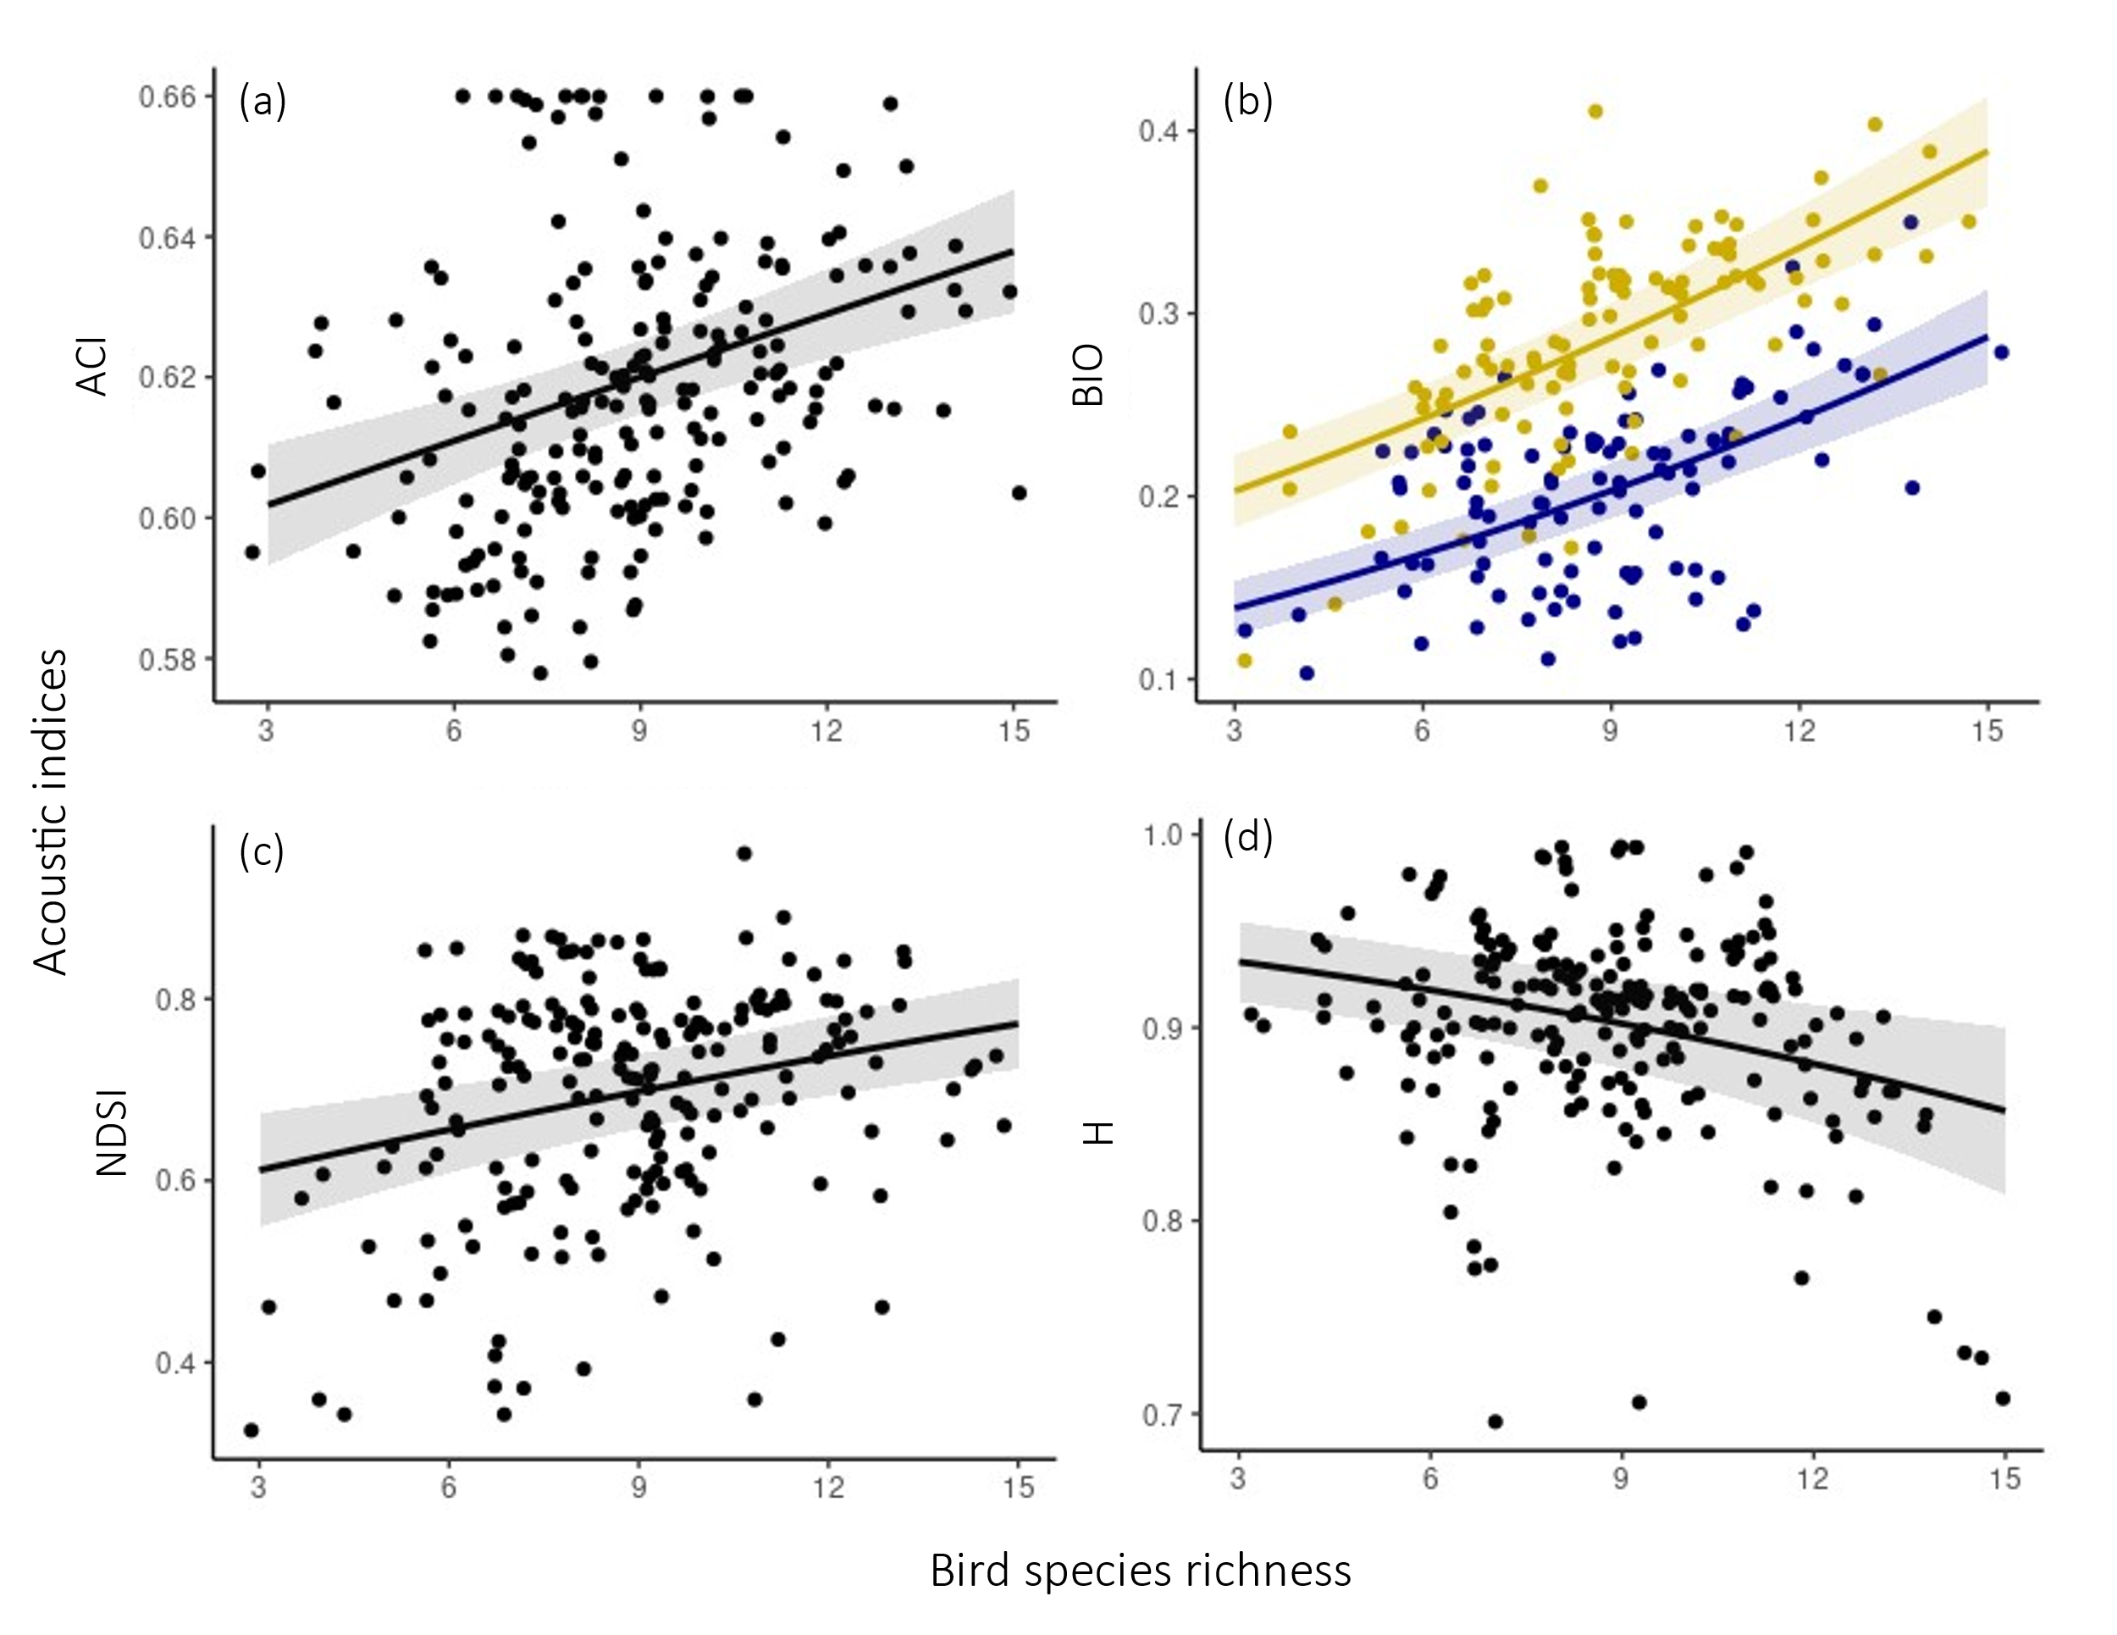
Figure 1. Significant relationships between bird species richness and standardised acoustic indices across 21 English vineyards (a): ACI: Acoustic Complexity Index; (b): BIO: Bioacoustic Index; (c): NDSI: Normalised Difference Soundscape Index; and (d): H: Acoustic Entropy Index. Lines represent model predicted values with 95% confidence intervals (shading) from generalised linear mixed models, and the points indicate raw standardised acoustic index values (jittered for clarity, n=208 samples). In (b), yellow = ‘morning’ recordings, and blue = ‘evening’ recordings, as these were significantly different from each other (see supporting information 2).
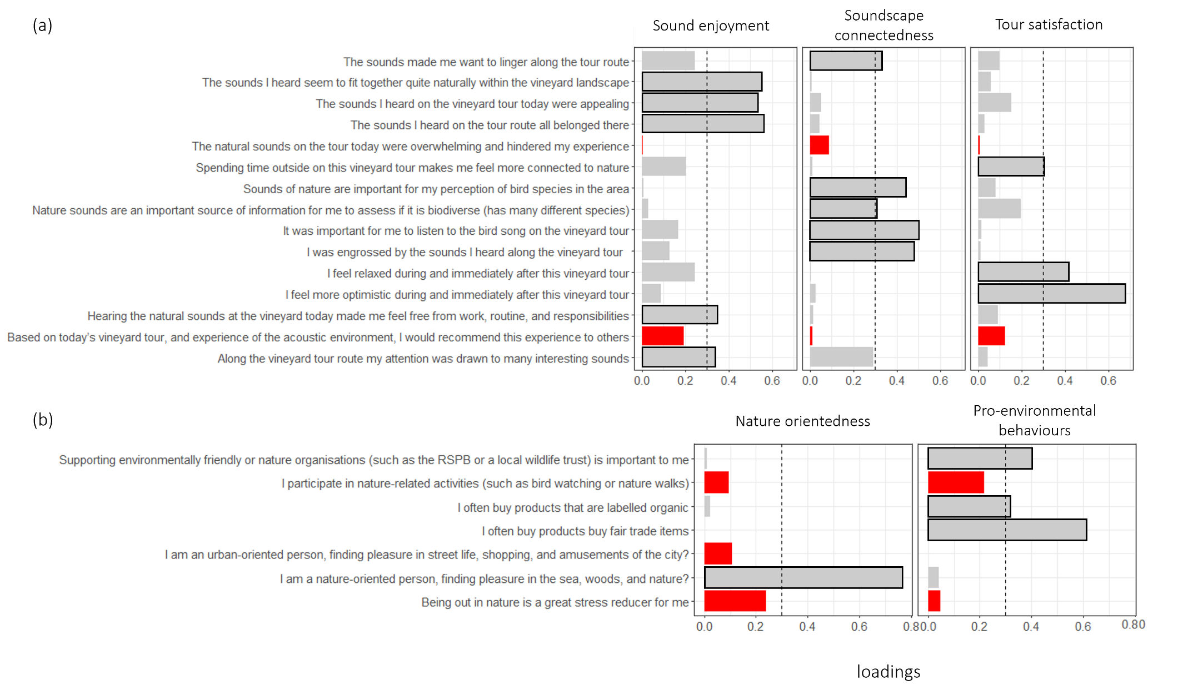
Figure 2. Explanatory factor analysis showing the factors (panel columns) and the associated communalities (loading squared) of each of the 15 statements that measured respondents’ vineyard tour experience (a), and the seven statements that measured respondents’ background interest in nature-related activities (b). Statements that loaded well (communality >0.3) onto one of the factors are marked by a black outline, and the red bars indicate statements that did not load well onto any other factors.
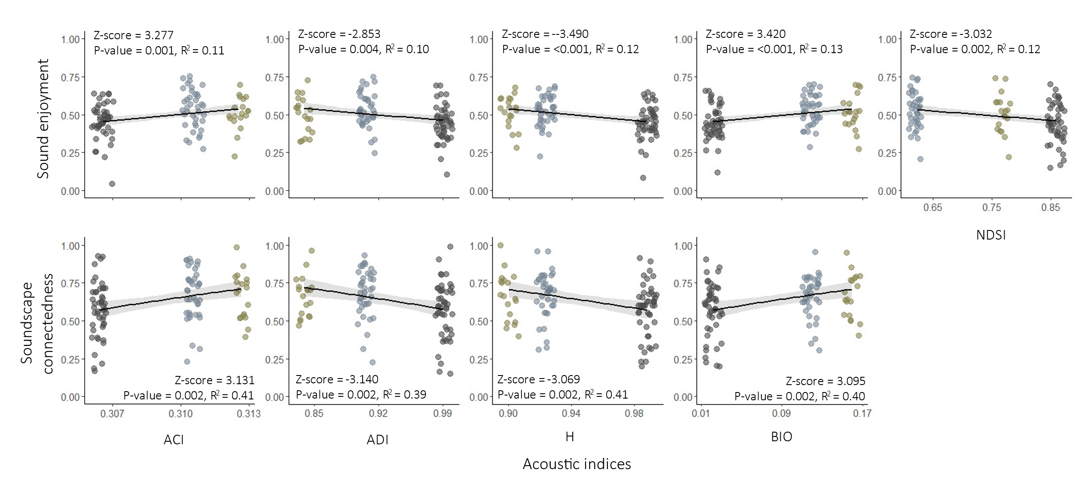
Figure 3. The relationship between five standardised acoustic indices (column panels – ACI: Acoustic Complexity Index; BIO: Bioacoustic Index; NDSI: Normalised Difference Soundscape Index; H: Acoustic Entropy Index; ADI: Acoustic Diversity Index), measured in the flowering season under ambient conditions, and two factor scores (row panels) describing respondents’ experience of vineyard tours: Sound enjoyment and Soundscape connectedness, where higher values indicate more positive experiences. Lines represents model predicted values with 95% confidence intervals (shading) from generalised linear mixed models. Points indicate raw factor scores (n=107) and are coloured per study site where the soundscape enhancement experiment took place, and they are jittered for clarity. Summary model outputs are given.
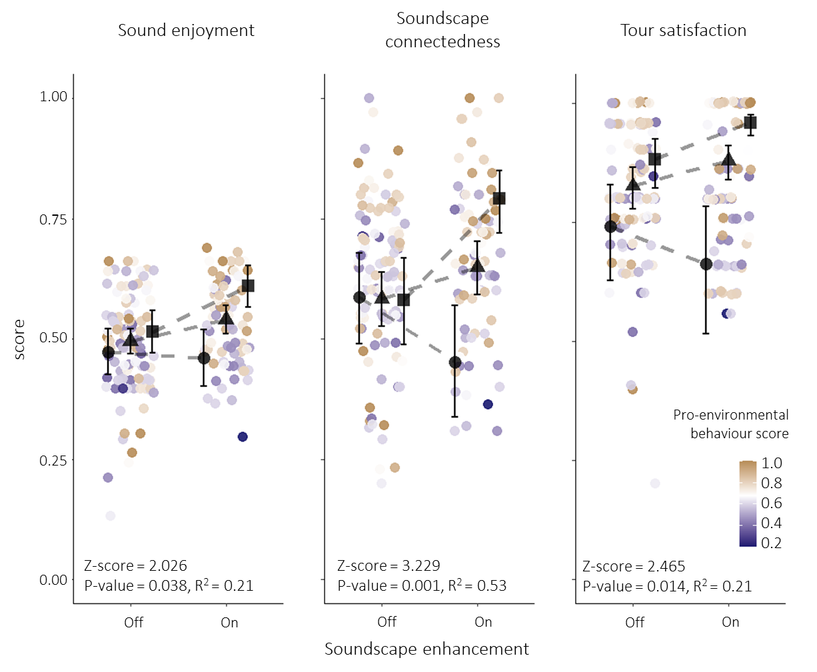
Figure 4. Impact of soundscape enhancement on respondents’ experience of vineyard tours, as summarised by three factor scores (panel columns). Coloured points indicate raw scores for the two conditions (n=107 for ‘off’ and n=79 for ‘on’) and the colour gradient relates to respondents’ pro-environmental behaviour factor score, with orange indicating higher scores, white indicating the mean, and blue indicating lower scores. Black points show model predicted scores (with 95% CI error bars) for the 1st quartile (circle, 0.31), mean (triangle, 0.68) and 3rd quartile (square, 0.80) value of the pro-environmental behaviours factor score, with the dashed line connecting the predictions between the ‘on’ and ‘off’ conditions. Summary model outputs of the interaction between the condition and pro-environmental behaviour score are included in each panel.
- Discussion
We demonstrate the link between bird species richness and soundscape complexity and volume in UK vineyards and show that soundscape characteristics can have a positive effect on vineyard visitors’ experience, increasing levels of reported soundscape connectedness and sound enjoyment. Our experimental soundscape enhancement demonstrates the direct contribution of the aural mode to improving our experiences of nature.
  - Relationship between bird diversity and acoustic indices
Sites and sampling seasons with higher avian species richness had more diverse and louder soundscapes. This closely mirrors patterns reported in similar studies from both tropical (Bradfer-Lawrence et al., 2019) and temperate systems (Eldridge et al., 2018), with larger bird communities resulting in a higher diversity of frequency bands being occupied and greater temporal variation in the sound energy across the soundscape. Bird activity is greatest in early mornings, so dawn soundscapes are expected to be louder and more diverse (Dröge et al., 2021). In support of this, we found higher BIO values in the mornings, which indicates higher amplitude of sounds (Boelman et al., 2007; Fuller et al., 2015; Pieretti et al., 2011). ADI, which measures soundscape evenness, did not predict species richness well. This could be because the relationship between soundscape evenness and species richness is not linear, with both quiet soundscapes with little song, and diverse soundscapes with continuous song, being characterised by high evenness; some studies have reported a weak decline in evenness with greater richness (e.g. Bradfer-Lawrence et al., 2019; Eldridge et al., 2018), with others reporting evenness to increase with species richness (e.g. Fuller et al., 2015; Mammides et al., 2017).
Contrary to other research (Boelman et al., 2007; Bradfer-Lawrence et al., 2019), we found no relationship between acoustic indices and bird abundance. This could be because abundance holds a comparatively weaker relationship with acoustic indices than species richness (Bradfer-Lawrence et al., 2020). Additionally, the species likely contributing most to soundscape complexity in our system are territorial and occur at low density, whilst the most abundant species, such as Woodpigeons Columba palumbus and Rooks Corvus frugilegus, are less vocal and have simple calls that are less likely to contribute to soundscape complexity. The difference may also arise from methodological differences between studies. For example, Boelman et al. (2007) and Bradfer-Lawrence et al. (2019) compared acoustic indices with diversity data collected at the same point in time, whilst we related bird diversity from a single point count to acoustic index values calculated across recording periods stretching weeks. Relative abundance can change rapidly over short periods of time, as animals move in relation to the recorders, whilst species richness stays more stable (Alcocer et al., 2022; Bradfer-Lawrence et al., 2023), and so, a snapshot measure of richness is more likely to be representative of avian contributions to local soundscapes over longer periods of time than an equivalent snapshot of abundance.
  - Effects of soundscape on vineyard visitors’ experience
We found a clear link between soundscape characteristics and vineyard visitors’ experience. The increase in reported soundscape connectedness and sound enjoyment with BIO indicate a positive association with soundscape volume, whilst the differences in responses with varying ACI, H and ADI values indicate a positive effect of soundscape complexity. Vineyard visitors who experienced the enhanced soundscapes showed stronger agreement with statements like ‘hearing natural sounds at the vineyard today made me feel free from work, routine and responsibilities’, which demonstrates that increased soundscape volume and complexity positively affect our wellbeing and contribute to a mindful experience of nature. This aligns with earlier findings that showed that bird diversity and birdsong have a positive effect on life satisfaction and wellbeing (Dallimer et al., 2012; Hammoud et al., 2022; Methorst et al., 2021), support restoration from stress and fatigue (Ratcliffe et al., 2013), and alleviate feelings of anxiety and paranoia (Stobbe et al., 2022). A sense of familiarity with sound can also enhance enjoyment and connectedness with soundscapes (Ednie & Gale, 2021), which could explain why vineyard visitors reported higher sound enjoyment at sites with lower NDSI values, indicative of lower ratios of biophony and anthrophony.
Soundscape enhancement had a significantly positive effect on both sound enjoyment, soundscape connectedness and tour satisfaction scores, crucially highlighting the direct contribution of the aural mode to visitors’ experiences. Our soundscape enhancement with birdsongs increased agreement with statements such as ‘the sounds I heard on the vineyard tour today were appealing’, ‘I was engrossed by the sounds I heard along the vineyard tour’ and ‘I feel relaxed during and immediately after this vineyard tour’, which showcases that natural sounds are an important part of the experience of nature and are noticed, even if subconsciously. Whilst similar effects of soundscape enhancement have been demonstrated on hiking trials (Ferraro et al., 2020), the patterns were not replicated under a laboratory setting that isolated the effect of aural stimuli (Douglas and Evans, 2022), raising questions as to whether sounds and sights associated with nature interact to deliver wellbeing benefits. Indeed, the results from the ‘off’ trials could arise because sound is a proxy for other habitat characteristics that can directly benefit wellbeing, such as the presence of hedgerows and woodland patches that host birds, or the perceived beauty of green spaces (Joye & Bolderdijk, 2015; Zhang et al., 2022). However, the experimental soundscape enhancement ensured only aural characteristics changed, and whilst it is noteworthy that there may have been minor variation in the exposure to playback for each participant due to differences in their standing position, speed of approach to the speaker or wind direction, our study kept any major additional modalities for nature engagement and physical activity stable. Regardless of the baseline and background sound levels, introducing additional birdsong into the ambient soundscape increased its complexity and volume, and the resultant increases in sound enjoyment, soundscape connectedness and tour satisfaction reinforce the specific contribution of birdsong to perceptions of biodiversity and delivery of benefits from nature engagement (Buckley, 2022; Douglas & Evans, 2022; Ferraro et al., 2020; Hammoud et al., 2022; Smalley et al., 2022; Stobbe et al., 2022). Importantly, we found the effect of soundscape enhancement to be supported across sites, regardless of their ambient soundscape characteristics, suggesting that there is capacity to improve health and wellbeing benefits from natural soundscapes through vineyard management practices that increase bird diversity (Paiola et al., 2020; Winter et al., 2018). We enhanced our soundscapes through the addition of songs from five species and further investigation could also identify whether the associated benefits continue to increase, level off, or even decline (Chmiel & Schubert, 2017), as more species are added, whilst also considering the interaction of birdsong with other sources of biophony and geophony, which were not measured in this study but have previously been shown to elicit feelings of connectedness (Ednie & Gale, 2021; Hallmann et al., 2017; Sharif et al., 2023).
At the individual level, the degree to which soundscapes alleviate mental fatigue and improve wellbeing can be influenced one’s connection with nature (Ratcliffe et al., 2013). Vineyard visitors who reported higher willingness to purchase organic or fair-trade foods scored higher for sound enjoyment and tour satisfaction. These individuals likely had higher levels of care for and awareness of nature, which in turn could have enhanced how much they connected to the vineyard soundscapes during tours (Barbro & Pickett, 2016; Soga & Gaston, 2016). Individual’s ability to be mindful and experience nature is positively correlated with their reported wellbeing and happiness (Barbaro & Pickett, 2016; Capaldi et al., 2014; Capstick et al., 2022), and may explain why our experimental soundscape enhancement had a more strongly positive effect on vineyard visitors with higher levels of pro-environmental behaviours. On the flip side, this highlights that individuals with lower levels of nature connectedness may benefit less from spending time in nature and from experiencing soundscapes, which is a cause for concern. Lower levels of nature connectedness are characteristic of the younger generations (Kesebir & Kesebir, 2017; Schweizer et al., 2007; Soga & Gaston, 2016), and our research reinforces that this patterns holds true for soundscapes, as vineyard visitors below 40 years of age connected less strongly to the vineyard soundscape than older visitors. It would be interesting to further research whether different groups of people benefit differently from exposure to soundscapes, and to better understand if efforts to improve biodiversity could be optimised to maximise the benefits for people arising from nature.
  - Conclusions
As biodiversity losses continue, particularly in agricultural areas (Rigal et al., 2023), and people’s access to greenspaces becomes more limited (Buxton et al., 2021; Morris et al., 2011), creating new and accessible opportunities to experience natural soundscapes, whilst also delivering biodiversity conservation, is vital. Given the importance of the tourism industry within viticulture (Sussex Modern, 2023), and given the positive link between soundscape complexity and visitors’ perception and experience, it is of particular value to vineyard managers to create complex natural soundscapes. At one extreme, this could potentially be achieved through artificial birdsong playback. However, this would require significant investment in technology and maintenance and would come without any conservation benefit. Furthermore, research has demonstrated that real-life experiences of nature lead to greater improvements in our mood and wellbeing compared to virtual or laboratory-based settings (Browning et al., 2020; Douglas & Evans, 2022). Instead, the ambition should be to increase bird richness in vineyards through, for example, diversification of habitats and ground cover, reduced chemical use (Barbaro et al., 2021; Zielonka et al., 2024), and the provision of nest boxes (Caprio & Rolando, 2017; Jedlicka et al., 2011). There could be potential monetary gains associated with investing in bird conservation measures in vineyards. Tourism loyalty (Jiang & Yan, 2022) and tourists’ wellbeing (Fisher et al., 2021) increase with positive soundscape perception and higher sound diversity, whilst natural sounds have been shown to alter consumer behaviour and affect food choices and sales (Kontukoski, 2018; Peng-Li et al., 2022). We hypothesise that complex and diverse vineyard soundscapes which enhance visitors’ experience could lead to them recommending their experience to others and translate to increased wine sales. This could lead to a win-win-win for biodiversity conservation, visitors’ wellbeing and business prosperity.
Biodiversity loss and the extinction of experience are linked and, together, they have serious consequences for our health and wellbeing (Bratman et al., 2019; IPBES, 2019). Natural soundscapes play an important role, and we argue that they should be recognised as natural capital and further incorporated into existing conservation policy (e.g IPBES Conceptual Framework - connecting nature and people; Díaz et al., 2015) to support actions required to protect and enhance natural soundscapes. Governmental agri-environment schemes are a major source of conservation funding across ‘working landscapes’ (Batáry et al., 2015) and support diversification practices that can effectively enhance diversity and the provision of regulating ecosystem services (e.g. biological pest control) within agricultural landscapes and positively affect production (Albrecht et al., 2020). We argue that these funding schemes, or indeed industry-specific sustainability schemes (Sigwalt et al., 2012; SWGB, 2020), should be extended to support management to conserve and enhance natural soundscapes, thus enriching nature’s contributions to visitors’ wellbeing and experience across vineyard landscapes.
References

Albrecht, M., Kleijn, D., Williams, N. M., Tschumi, M., Blaauw, B. R., Bommarco, R., Campbell, A. J., Dainese, M., Drummond, F. A., Entling, M. H., Ganser, D., Arjen de Groot, G., Goulson, D., Grab, H., Hamilton, H., Herzog, F., Isaacs, R., Jacot, K., Jeanneret, P., … Sutter, L. (2020). The effectiveness of flower strips and hedgerows on pest control, pollination services and crop yield: A quantitative synthesis. Ecology Letters, 23(10), 1488–1498. https://doi.org/10.1111/ele.13576
Alcocer, I., Lima, H., Sugai, L. S. M., & Llusia, D. (2022). Acoustic indices as proxies for biodiversity: A meta-analysis. Biological Reviews, 97(6), 2209–2236. https://doi.org/10.1111/brv.12890
Assandri, G., Bogliani, G., Pedrini, P., & Brambilla, M. (2016). Diversity in the monotony? Habitat traits and management practices shape avian communities in intensive vineyards. Agriculture, Ecosystems & Environment, 223, 250–260. https://doi.org/10.1016/j.agee.2016.03.014
Astell-Burt, T., & Feng, X. (2019). Association of Urban Green Space With Mental Health and General Health Among Adults in Australia. JAMA Network Open, 2(7), e198209. https://doi.org/10.1001/jamanetworkopen.2019.8209
Barbaro, Assandri, G., Brambilla, M., Castagneyrol, B., Froidevaux, J., Giffard, B., Pithon, J., Puig-Montserrat, X., Torre, I., Calatayud, F., Gaüzère, P., Guenser, J., Macià-Valverde, F.-X., Mary, S., Raison, L., Sirami, C., & Rusch, A. (2021). Organic management and landscape heterogeneity combine to sustain multifunctional bird communities in European vineyards. Journal of Applied Ecology, 58(6), 1261–1271. https://doi.org/10.1111/1365-2664.13885
Barbaro, & Pickett, S. M. (2016). Mindfully green: Examining the effect of connectedness to nature on the relationship between mindfulness and engagement in pro-environmental behavior. Personality and Individual Differences, 93, 137–142. https://doi.org/10.1016/j.paid.2015.05.026
Bartlett, M. S. (1951). The Effect of Standardization on a χ2 Approximation in Factor Analysis. Biometrika, 38(3/4), 337–344. https://doi.org/10.2307/2332580
Batáry, P., Dicks, L. V., Kleijn, D., & Sutherland, W. J. (2015). The role of agri-environment schemes in conservation and environmental management. Conservation Biology, 29(4), 1006–1016. https://doi.org/10.1111/cobi.12536
Benfield, J. A., Taff, B. D., Newman, P., & Smyth, J. (2014). Natural Sound Facilitates Mood Recovery. Ecopsychology, 6(3), 183–188. https://doi.org/10.1089/eco.2014.0028
Bibby, C. J., Burgess, N. D., Hill, D. A., & Mustoe, S. H. (2000). Bird census techniques. Academic Press.
Boelman, N. T., Asner, G. P., Hart, P. J., & Martin, R. E. (2007). Multi-Trophic Invasion Resistance in Hawaii: Bioacoustics, Field Surveys, and Airborne Remote Sensing. Ecological Applications, 17(8), 2137–2144. https://doi.org/10.1890/07-0004.1
Bradfer-Lawrence, T., Bunnefeld, N., Gardner, N., Willis, S. G., & Dent, D. H. (2020). Rapid assessment of avian species richness and abundance using acoustic indices. Ecological Indicators, 115, 106400. https://doi.org/10.1016/j.ecolind.2020.106400
Bradfer-Lawrence, T., Desjonqueres, C., Eldridge, A., Johnston, A., & Metcalf, O. (2023). Using acoustic indices in ecology: Guidance on study design, analyses and interpretation. Methods in Ecology and Evolution, n/a(n/a). https://doi.org/10.1111/2041-210X.14194
Bradfer-Lawrence, T., Gardner, N., Bunnefeld, L., Bunnefeld, N., Willis, S. G., & Dent, D. H. (2019). Guidelines for the use of acoustic indices in environmental research. Methods in Ecology and Evolution, 10(10), 1796–1807. https://doi.org/10.1111/2041-210X.13254
Brambilla, M., Ilahiane, L., Assandri, G., Ronchi, S., & Bogliani, G. (2017). Combining habitat requirements of endemic bird species and other ecosystem services may synergistically enhance conservation efforts. Science of The Total Environment, 586, 206–214. https://doi.org/10.1016/j.scitotenv.2017.01.203
Bratman, G. N., Anderson, C. B., Berman, M. G., Cochran, B., de Vries, S., Flanders, J., Folke, C., Frumkin, H., Gross, J. J., Hartig, T., Kahn, P. H., Kuo, M., Lawler, J. J., Levin, P. S., Lindahl, T., Meyer-Lindenberg, A., Mitchell, R., Ouyang, Z., Roe, J., … Daily, G. C. (2019). Nature and mental health: An ecosystem service perspective. Science Advances, 5(7), eaax0903. https://doi.org/10.1126/sciadv.aax0903
Brooks, M. E., Kristensen, K., van Benthem, K. J., Magnusson, A., Berg, C. W., Nielsen, A., Skaug, H. J., Machler, M., & Bolker, B. M. (2017). glmmTMB balances speed and flexibility among packages for zero-inflated generalized linear mixed modeling. The R Journal, 9(2), 378–400. https://doi.org/10.3929/ethz-b-000240890
Browning, M. H. E. M., Shipley, N., McAnirlin, O., Becker, D., Yu, C.-P., Hartig, T., & Dzhambov, A. M. (2020). An Actual Natural Setting Improves Mood Better Than Its Virtual Counterpart: A Meta-Analysis of Experimental Data. Frontiers in Psychology, 11. https://www.frontiersin.org/articles/10.3389/fpsyg.2020.02200
Brumm, H. (2009). Song amplitude and body size in birds. Behavioral Ecology and Sociobiology, 63(8), 1157–1165. https://doi.org/10.1007/s00265-009-0743-4
Brumm, H., & Todt, D. (2002). Noise-dependent song amplitude regulation in a territorial songbird. Animal Behaviour, 63(5), 891–897. https://doi.org/10.1006/anbe.2001.1968
Buckley, R. C. (2022). Sensory and Emotional Components in Tourist Memories of Wildlife Encounters: Intense, Detailed, and Long-Lasting Recollections of Individual Incidents. Sustainability, 14(8), Article 8. https://doi.org/10.3390/su14084460
Burns, F., Eaton, M. A., Burfield, I. J., Klvaňová, A., Šilarová, E., Staneva, A., & Gregory, R. D. (2021). Abundance decline in the avifauna of the European Union reveals cross-continental similarities in biodiversity change. Ecology and Evolution, 11(23), 16647–16660. https://doi.org/10.1002/ece3.8282
Burns, F., Mordue, S., al Fulaij, N., Boersch-Supan, P., Boswell, J., Bradfer-Lawrence, T., de Ornellas, P., de Palma, A., de Zylva, P., Dennis, E., Foster, S., Gilbert, G., Halliwell, L., Hawkins, K., Haysom, K., Holland, M., Hughes, J., Jackson, A., Mancini, F., … Gregory, R. (2023). State of Nature 2023. The State of Nature Partnership. www.stateofnature.org.uk
Buxton, R. T., Pearson, A. L., Allou, C., Fristrup, K., & Wittemyer, G. (2021). A synthesis of health benefits of natural sounds and their distribution in national parks. Proceedings of the National Academy of Sciences, 118(14), e2013097118. https://doi.org/10.1073/pnas.2013097118
Capaldi, C. A., Dopko, R. L., & Zelenski, J. M. (2014). The relationship between nature connectedness and happiness: A meta-analysis. Frontiers in Psychology, 5(976). https://doi.org/10.3389/fpsyg.2014.00976
Caprio, E., & Rolando, A. (2017). Management systems may affect the feeding ecology of great tits Parus major nesting in vineyards. Agriculture, Ecosystems & Environment, 243, 67–73. https://doi.org/10.1016/j.agee.2017.03.013
Capstick, S., Nash, N., Whitmarsh, L., Poortinga, W., Haggar, P., & Brügger, A. (2022). The connection between subjective wellbeing and pro-environmental behaviour: Individual and cross-national characteristics in a seven-country study. Environmental Science & Policy, 133, 63–73. https://doi.org/10.1016/j.envsci.2022.02.025
Carrus, G., Scopelliti, M., Panno, A., Lafortezza, R., Colangelo, G., Pirchio, S., Ferrini, F., Salbitano, F., Agrimi, M., Portoghesi, L., Semenzato, P., & Sanesi, G. (2017). A Different Way to Stay in Touch with ‘Urban Nature’: The Perceived Restorative Qualities of Botanical Gardens. Frontiers in Psychology, 8. https://www.frontiersin.org/articles/10.3389/fpsyg.2017.00914
Chmiel, A., & Schubert, E. (2017). Back to the inverted-U for music preference: A review of the literature. Psychology of Music, 45(6), 886–909. https://doi.org/10.1177/0305735617697507
Cox, D. T. C., & Gaston, K. J. (2018). Human–nature interactions and the consequences and drivers of provisioning wildlife. Philosophical Transactions of the Royal Society B: Biological Sciences, 373(1745), 20170092. https://doi.org/10.1098/rstb.2017.0092
Cribari-Neto, F., & Zeileis, A. (2010). Beta Regression in R. Journal of Statistical Software, 34(2). https://doi.org/10.18637/jss.v034.i02
Dallimer, M., Irvine, K. N., Skinner, A. M. J., Davies, Z. G., Rouquette, J. R., Maltby, L. L., Warren, P. H., Armsworth, P. R., & Gaston, K. J. (2012). Biodiversity and the Feel-Good Factor: Understanding Associations between Self-Reported Human Well-being and Species Richness. BioScience, 62(1), 47–55. https://doi.org/10.1525/bio.2012.62.1.9
DEFRA. (2022). Wild bird populations in the UK, 1970 to 2022. GOV.UK. https://www.gov.uk/government/statistics/wild-bird-populations-in-the-uk/wild-bird-populations-in-the-uk-1970-to-2021
Díaz, S., Demissew, S., Carabias, J., Joly, C., Lonsdale, M., Ash, N., Larigauderie, A., Adhikari, J. R., Arico, S., Báldi, A., Bartuska, A., Baste, I. A., Bilgin, A., Brondizio, E., Chan, K. M., Figueroa, V. E., Duraiappah, A., Fischer, M., Hill, R., … Zlatanova, D. (2015). The IPBES Conceptual Framework—Connecting nature and people. Current Opinion in Environmental Sustainability, 14, 1–16. https://doi.org/10.1016/j.cosust.2014.11.002
Díaz, S., Settele, J., Brondízio, E. S., Ngo, H. T., Agard, J., Arneth, A., Balvanera, P., Brauman, K. A., Butchart, S. H. M., Chan, K. M. A., Garibaldi, L. A., Ichii, K., Liu, J., Subramanian, S. M., Midgley, G. F., Miloslavich, P., Molnár, Z., Obura, D., Pfaff, A., … Zayas, C. N. (2019). Pervasive human-driven decline of life on Earth points to the need for transformative change. Science, 366(6471), eaax3100. https://doi.org/10.1126/science.aax3100
Douglas, J. W. A., & Evans, K. L. (2022). An experimental test of the impact of avian diversity on attentional benefits and enjoyment of people experiencing urban green‐space. People and Nature, 4(1), Article 1. https://eprints.whiterose.ac.uk/182282/
Dröge, S., Martin, D. A., Andriafanomezantsoa, R., Burivalova, Z., Fulgence, T. R., Osen, K., Rakotomalala, E., Schwab, D., Wurz, A., Richter, T., & Kreft, H. (2021). Listening to a changing landscape: Acoustic indices reflect bird species richness and plot-scale vegetation structure across different land-use types in north-eastern Madagascar. Ecological Indicators, 120, 106929. https://doi.org/10.1016/j.ecolind.2020.106929
Ednie, A., & Gale, T. (2021). Soundscapes and protected area conservation: Are noises in nature making people complacent? Nature Conservation, 44, 177–195. https://doi.org/10.3897/natureconservation.44.69578
Eldridge, A., Guyot, P., Moscoso, P., Johnston, A., Eyre-Walker, Y., & Peck, M. (2018). Sounding out ecoacoustic metrics: Avian species richness is predicted by acoustic indices in temperate but not tropical habitats. Ecological Indicators, 95, 939–952. https://doi.org/10.1016/j.ecolind.2018.06.012
Engemann, K., Pedersen, C. B., Arge, L., Tsirogiannis, C., Mortensen, P. B., & Svenning, J.-C. (2019). Residential green space in childhood is associated with lower risk of psychiatric disorders from adolescence into adulthood. Proceedings of the National Academy of Sciences, 116(11), 5188–5193. https://doi.org/10.1073/pnas.1807504116
Fairbrass, A. J., Rennert, P., Williams, C., Titheridge, H., & Jones, K. E. (2017). Biases of acoustic indices measuring biodiversity in urban areas. Ecological Indicators, 83, 169–177. https://doi.org/10.1016/j.ecolind.2017.07.064
Ferrari, S., & Cribari-Neto, F. (2004). Beta Regression for Modelling Rates and Proportions. Journal of Applied Statistics, 31(7), 799–815. https://doi.org/10.1080/0266476042000214501
Ferraro, D. M., Miller, Z. D., Ferguson, L. A., Taff, B. D., Barber, J. R., Newman, P., & Francis, C. D. (2020). The phantom chorus: Birdsong boosts human well-being in protected areas. Proceedings of the Royal Society B: Biological Sciences, 287(1941), 20201811. https://doi.org/10.1098/rspb.2020.1811
Fesenko, I., & García-Rosell, J.-C. (2019). An acoustic perspective on nature-based tourism experience – The soundscape of dog sledding, Lapland. Matkailututkimus, 15(1), Article 1. https://doi.org/10.33351/mt.84315
Fisher, J. C., Irvine, K. N., Bicknell, J. E., Hayes, W. M., Fernandes, D., Mistry, J., & Davies, Z. G. (2021). Perceived biodiversity, sound, naturalness and safety enhance the restorative quality and wellbeing benefits of green and blue space in a neotropical city. Science of The Total Environment, 755, 143095. https://doi.org/10.1016/j.scitotenv.2020.143095
Fuller, S., Axel, A. C., Tucker, D., & Gage, S. H. (2015). Connecting soundscape to landscape: Which acoustic index best describes landscape configuration? Ecological Indicators, 58, 207–215. https://doi.org/10.1016/j.ecolind.2015.05.057
Gasc, A., Francomano, D., Dunning, J. B., & Pijanowski, B. C. (2017). Future directions for soundscape ecology: The importance of ornithological contributions. The Auk, 134(1), 215–228. https://doi.org/10.1642/AUK-16-124.1
Gaston, K. J., & Soga, M. (2020). Extinction of experience: The need to be more specific. People and Nature, 2(3), 575–581. https://doi.org/10.1002/pan3.10118
Geldenhuys, M., Gaigher, R., Pryke, J. S., & Samways, M. J. (2022). Vineyards compared to natural vegetation maintain high arthropod species turnover but alter trait diversity and composition of assemblages. Agriculture, Ecosystems & Environment, 336, 108043. https://doi.org/10.1016/j.agee.2022.108043
Hallmann, C. A., Sorg, M., Jongejans, E., Siepel, H., Hofland, N., Schwan, H., Stenmans, W., Müller, A., Sumser, H., Hörren, T., Goulson, D., & Kroon, H. de. (2017). More than 75 percent decline over 27 years in total flying insect biomass in protected areas. PLOS ONE, 12(10), e0185809. https://doi.org/10.1371/journal.pone.0185809
Hammoud, R., Tognin, S., Burgess, L., Bergou, N., Smythe, M., Gibbons, J., Davidson, N., Afifi, A., Bakolis, I., & Mechelli, A. (2022). Smartphone-based ecological momentary assessment reveals mental health benefits of birdlife. Scientific Reports, 12(1), Article 1. https://doi.org/10.1038/s41598-022-20207-6
Hedblom, M., Heyman, E., Antonsson, H., & Gunnarsson, B. (2014). Bird song diversity influences young people’s appreciation of urban landscapes. Urban Forestry & Urban Greening, 13(3), 469–474. https://doi.org/10.1016/j.ufug.2014.04.002
Hill, A. P., Prince, P., Snaddon, J. L., Doncaster, C. P., & Rogers, A. (2019). AudioMoth: A low-cost acoustic device for monitoring biodiversity and the environment. HardwareX, 6, e00073. https://doi.org/10.1016/j.ohx.2019.e00073
Inger, R., Gregory, R., Duffy, J. P., Stott, I., Voříšek, P., & Gaston, K. J. (2015). Common European birds are declining rapidly while less abundant species’ numbers are rising. Ecology Letters, 18(1), 28–36. https://doi.org/10.1111/ele.12387
IPBES. (2019). Global assessment report on biodiversity and ecosystem services of the Intergovernmental Science-Policy Platform on Biodiversity and Ecosystem Services (Version 1). Zenodo. https://doi.org/10.5281/ZENODO.3831673
Jedlicka, J. A., Greenberg, R., & Letourneau, D. K. (2011). Avian Conservation Practices Strengthen Ecosystem Services in California Vineyards. PLOS ONE, 6(11), e27347. https://doi.org/10.1371/journal.pone.0027347
Jiang, J., & Yan, B. (2022). From soundscape participation to tourist loyalty in nature-based tourism: The moderating role of soundscape emotion and the mediating role of soundscape satisfaction. Journal of Destination Marketing & Management, 26, 100730. https://doi.org/10.1016/j.jdmm.2022.100730
Johnson, C. N., Balmford, A., Brook, B. W., Buettel, J. C., Galetti, M., Guangchun, L., & Wilmshurst, J. M. (2017). Biodiversity losses and conservation responses in the Anthropocene. Science, 356(6335), 270–275. https://doi.org/10.1126/science.aam9317
Joye, Y., & Bolderdijk, J. W. (2015). An exploratory study into the effects of extraordinary nature on emotions, mood, and prosociality. Frontiers in Psychology, 5. https://www.frontiersin.org/articles/10.3389/fpsyg.2014.01577
Kaiser, H. F. (1970). A second generation little jiffy. Psychometrika, 35(4), 401–415. https://doi.org/10.1007/BF02291817
Kasten, E. P., Gage, S. H., Fox, J., & Joo, W. (2012). The remote environmental assessment laboratory’s acoustic library: An archive for studying soundscape ecology. Ecological Informatics, 12, 50–67. https://doi.org/10.1016/j.ecoinf.2012.08.001
Kendon, M. (2022). Unprecedented extreme heatwave, July 2022. Met Office National Climate Information Centre. https://www.metoffice.gov.uk/binaries/content/assets/metofficegovuk/pdf/weather/learn-about/uk-past-events/interesting/2022/2022_03_july_heatwave_v1.pdf
Kesebir, S., & Kesebir, P. (2017). A Growing Disconnection From Nature Is Evident in Cultural Products. Perspectives on Psychological Science, 12(2), 258–269. https://doi.org/10.1177/1745691616662473
Klepeis, N. E., Nelson, W. C., Ott, W. R., Robinson, J. P., Tsang, A. M., Switzer, P., Behar, J. V., Hern, S. C., & Engelmann, W. H. (2001). The National Human Activity Pattern Survey (NHAPS): A resource for assessing exposure to environmental pollutants. Journal of Exposure Science & Environmental Epidemiology, 11(3), Article 3. https://doi.org/10.1038/sj.jea.7500165
Kontukoski, M. (2018). Nature sounds in a hypermarket. A case study on the modified soundscape of commercial spaces in Finland. Etnomusikologian Vuosikirja, 30, 92–120. https://doi.org/10.23985/evk.69118
Luther, D. A., Danner, R., Danner, J., Gentry, K., & Derryberry, E. P. (2017). The relative response of songbirds to shifts in song amplitude and song minimum frequency. Behavioral Ecology, 28(2), 391–397. https://doi.org/10.1093/beheco/arw172
Mammides, C., Goodale, E., Dayananda, S. K., Kang, L., & Chen, J. (2017). Do acoustic indices correlate with bird diversity? Insights from two biodiverse regions in Yunnan Province, south China. Ecological Indicators, 82, 470–477. https://doi.org/10.1016/j.ecolind.2017.07.017
Methorst, J., Rehdanz, K., Mueller, T., Hansjürgens, B., Bonn, A., & Böhning-Gaese, K. (2021). The importance of species diversity for human well-being in Europe. Ecological Economics, 181, 106917. https://doi.org/10.1016/j.ecolecon.2020.106917
Mikołajczak, K., Lees, A. C., Barlow, J., Sinclair, F., Trindade De Almeida, O., Souza, A. C., & Parry, L. (2021). Who knows, who cares? Untangling ecological knowledge and nature connection among Amazonian colonist farmers. People and Nature, 3(2), 431–445. https://doi.org/10.1002/pan3.10183
Moreno-Gómez, F. N., Bartheld, J., Silva-Escobar, A. A., Briones, R., Márquez, R., & Penna, M. (2019). Evaluating acoustic indices in the Valdivian rainforest, a biodiversity hotspot in South America. Ecological Indicators, 103, 1–8. https://doi.org/10.1016/j.ecolind.2019.03.024
Morris, J., O’Brien, E., Ambrose-Oji, B., Lawrence, A., Carter, C., & Peace, A. (2011). Access for all? Barriers to accessing woodlands and forests in Britain. Local Environment, 16(4), 375–396. https://doi.org/10.1080/13549839.2011.576662
Morrison, C. A., Auniņš, A., Benkő, Z., Brotons, L., Chodkiewicz, T., Chylarecki, P., Escandell, V., Eskildsen, D. P., Gamero, A., Herrando, S., Jiguet, F., Kålås, J. A., Kamp, J., Klvaňová, A., Kmecl, P., Lehikoinen, A., Lindström, Å., Moshøj, C., Noble, D. G., … Butler, S. J. (2021). Bird population declines and species turnover are changing the acoustic properties of spring soundscapes. Nature Communications, 12(1), Article 1. https://doi.org/10.1038/s41467-021-26488-1
Nesbitt, A., Dorling, S., & Jones, R. (2019). Climate resilience in the United Kingdom wine production sector: CREWS-UK. BIO Web of Conferences, 15, 01011. https://doi.org/10.1051/bioconf/20191501011
NHS England. (n.d.). NHS England » Green social prescribing. Retrieved October 4, 2023, from https://www.england.nhs.uk/personalisedcare/social-prescribing/green-social-prescribing/
O’Brien, L., McConnachie, S., Hall, C., Forster, J., Dyke, A., Saraev, V., & Jones, G. (2024). Exploring the social and cultural values of trees and woodlands in England: A new composite measure. People and Nature, pan3.10644. https://doi.org/10.1002/pan3.10644
Olden, J. D., Poff, N. L., Douglas, M. R., Douglas, M. E., & Fausch, K. D. (2004). Ecological and evolutionary consequences of biotic homogenization. Trends in Ecology & Evolution, 19(1), 18–24. https://doi.org/10.1016/j.tree.2003.09.010
Paiola, A., Assandri, G., Brambilla, M., Zottini, M., Pedrini, P., & Nascimbene, J. (2020). Exploring the potential of vineyards for biodiversity conservation and delivery of biodiversity-mediated ecosystem services: A global-scale systematic review. Science of The Total Environment, 706, 135839. https://doi.org/10.1016/j.scitotenv.2019.135839
Payne, S. R. (2013). The production of a Perceived Restorativeness Soundscape Scale. Applied Acoustics, 74(2), 255–263. https://doi.org/10.1016/j.apacoust.2011.11.005
Peng-Li, D., Andersen, T., Finlayson, G., Byrne, D. V., & Wang, Q. J. (2022). The impact of environmental sounds on food reward. Physiology & Behavior, 245, 113689. https://doi.org/10.1016/j.physbeh.2021.113689
Pieretti, N., Farina, A., & Morri, D. (2011). A new methodology to infer the singing activity of an avian community: The Acoustic Complexity Index (ACI). Ecological Indicators, 11(3), 868–873. https://doi.org/10.1016/j.ecolind.2010.11.005
Pithon, J. A., Beaujouan, V., Daniel, H., Pain, G., & Vallet, J. (2016). Are vineyards important habitats for birds at local or landscape scales? Basic and Applied Ecology, 17(3), 240–251. https://doi.org/10.1016/j.baae.2015.12.004
R Core Team. (2021). R: A language and environment for statistical computing. (4.3.0) [Computer software]. R Foundation for Statistical Computing. https://www.R-project.org/
Ratcliffe, E. (2021). Sound and Soundscape in Restorative Natural Environments: A Narrative Literature Review. Frontiers in Psychology, 12. https://www.frontiersin.org/articles/10.3389/fpsyg.2021.570563
Ratcliffe, E., Gatersleben, B., & Sowden, P. T. (2013). Bird sounds and their contributions to perceived attention restoration and stress recovery. Journal of Environmental Psychology, 36, 221–228. https://doi.org/10.1016/j.jenvp.2013.08.004
Reif, J., & Vermouzek, Z. (2019). Collapse of farmland bird populations in an Eastern European country following its EU accession. Conservation Letters, 12(1), e12585. https://doi.org/10.1111/conl.12585
Revelle, W. (2024). _psych: Procedures for Psychological, Psychometric, and Personality Research_. (R package version 2.4.3,) [Computer software]. https://CRAN.R-project.org/package=psych
Richardson, E. A., & Mitchell, R. (2010). Gender differences in relationships between urban green space and health in the United Kingdom. Social Science & Medicine, 71(3), 568–575. https://doi.org/10.1016/j.socscimed.2010.04.015
Rigal, S., Dakos, V., Alonso, H., Auniņš, A., Benkő, Z., Brotons, L., Chodkiewicz, T., Chylarecki, P., de Carli, E., del Moral, J. C., Domşa, C., Escandell, V., Fontaine, B., Foppen, R., Gregory, R., Harris, S., Herrando, S., Husby, M., Ieronymidou, C., … Devictor, V. (2023). Farmland practices are driving bird population decline across Europe. Proceedings of the National Academy of Sciences, 120(21), e2216573120. https://doi.org/10.1073/pnas.2216573120
Rosenberg, K. V., Dokter, A. M., Blancher, P. J., Sauer, J. R., Smith, A. C., Smith, P. A., Stanton, J. C., Panjabi, A., Helft, L., Parr, M., & Marra, P. P. (2019). Decline of the North American avifauna. Science, 366(6461), 120–124. https://doi.org/10.1126/science.aaw1313
Schebella, M. F., Weber, D., Lindsey, K., & Daniels, C. B. (2017). For the Love of Nature: Exploring the Importance of Species Diversity and Micro-Variables Associated with Favorite Outdoor Places. Frontiers in Psychology, 8. https://www.frontiersin.org/articles/10.3389/fpsyg.2017.02094
Schweizer, C., Edwards, R. D., Bayer-Oglesby, L., Gauderman, W. J., Ilacqua, V., Juhani Jantunen, M., Lai, H. K., Nieuwenhuijsen, M., & Künzli, N. (2007). Indoor time–microenvironment–activity patterns in seven regions of Europe. Journal of Exposure Science & Environmental Epidemiology, 17(2), Article 2. https://doi.org/10.1038/sj.jes.7500490
Sharif, M. Z., Di, N., & Yu, B. (2023). Honeybee (Apis spp.) (Hymenoptera: Apidae) Colony Monitoring Using Acoustic Signals from the Beehive: An Assessment by Global Experts and Our Feedback. Agriculture, 13(4), Article 4. https://doi.org/10.3390/agriculture13040769
Sigwalt, A., Pain, G., Pancher, A., & Vincent, A. (2012). Collective Innovation Boosts Biodiversity in French Vineyards. Journal of Sustainable Agriculture, 36(3), 337–352. https://doi.org/10.1080/10440046.2011.654008
Smalley, A. J., White, M. P., Ripley, R., Atack, T. X., Lomas, E., Sharples, M., Coates, P. A., Groom, N., Grand, A., Heneberry, A., Fleming, L. E., & Depledge, M. H. (2022). Forest 404: Using a BBC drama series to explore the impact of nature’s changing soundscapes on human wellbeing and behavior. Global Environmental Change, 74, 102497. https://doi.org/10.1016/j.gloenvcha.2022.102497
Soga, M., & Gaston, K. J. (2016). Extinction of experience: The loss of human–nature interactions. Frontiers in Ecology and the Environment, 14(2), 94–101. https://doi.org/10.1002/fee.1225
Stobbe, E., Sundermann, J., Ascone, L., & Kühn, S. (2022). Birdsongs alleviate anxiety and paranoia in healthy participants. Scientific Reports, 12(1), Article 1. https://doi.org/10.1038/s41598-022-20841-0
Sueur, J., AUBIN, T., & Simonis, C. (2008). Seewave, a Free Modular Tool for Sound Analysis and Synthesis. Bioacoustics, 18(2), 213–226. https://doi.org/10.1080/09524622.2008.9753600
Sussex Modern. (2023). Sussex Wine Tourism: A Plan for Growth. https://sussexmodern.org.uk/sussexwinetourism/
SWGB. (2020). “WineGB Now has its Own Sustainability Scheme.”. WineGB Annual Report. https://www. winegb.co.uk/wp-content/uploads/2020/06/SWGBarticle-in-Grape-Press-May-2020.pdf.
Uebel, K., Marselle, M., Dean, A. J., Rhodes, J. R., & Bonn, A. (2021). Urban green space soundscapes and their perceived restorativeness. People and Nature, 3(3), 756–769. https://doi.org/10.1002/pan3.10215
Villanueva-Rivera, L. J., & Pijanowski, B. C. (2018). soundecology: Soundscape Ecology (1 (3)) [Computer software]. https://cran.r-project.org/web/packages/soundecology/soundecology.pdf
Villanueva-Rivera, L. J., Pijanowski, B. C., Doucette, J., & Pekin, B. (2011). A primer of acoustic analysis for landscape ecologists. Landscape Ecology, 26(9), 1233–1246. https://doi.org/10.1007/s10980-011-9636-9
Weinzimmer, D., Newman, P., Taff, D., Benfield, J., Lynch, E., & Bell, P. (2014). Human Responses to Simulated Motorized Noise in National Parks. Leisure Sciences, 36(3), 251–267. https://doi.org/10.1080/01490400.2014.888022
Winter, S., Bauer, T., Strauss, P., Kratschmer, S., Paredes, D., Popescu, D., Landa, B., Guzmán, G., Gómez, J. A., Guernion, M., Zaller, J. G., & Batáry, P. (2018). Effects of vegetation management intensity on biodiversity and ecosystem services in vineyards: A meta-analysis. The Journal of Applied Ecology, 55(5), 2484–2495. https://doi.org/10.1111/1365-2664.13124
Zhang, C., Wang, C., Chen, C., Tao, L., Jin, J., Wang, Z., & Jia, B. (2022). Effects of tree canopy on psychological distress: A repeated cross-sectional study before and during the COVID-19 epidemic. Environmental Research, 203, 111795. https://doi.org/10.1016/j.envres.2021.111795
Zielonka, N. B., Shutt, J. D., Butler, S. J., & Dicks, L. V. (2024). Management practices, and not surrounding habitats, drive bird and arthropod biodiversity within vineyards. Agriculture, Ecosystems & Environment, 367, 108982. https://doi.org/10.1016/j.agee.2024.108982

